Musical Instruments Out of Trash
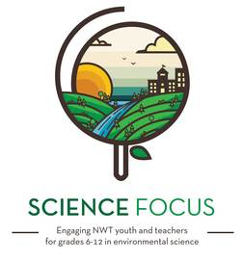

Topic
- Waste

Objective
- Have some fun and learn a bit about recycling.

Environmental Education Activity

Age/Grade Range
- Age 5-10

Group Size
- Up to 30 students

Time
- Prep time: 30 minutes
- Set-up: 5-10 minutes
- Activity: 30 min

Materials
- Lots of ‘trash’ (containers, boxes, cans, Styrofoam trays, corks, chopsticks, toilet paper or poster rolls, fabric scraps, magazine clippings…)
- Elastic bands
- Rice, barely or small pebbles for shakers
- Craft supplies (glue, scissors, masking tape, duct tape and any sequins, feathers or other decorative things you can find)

Set Up
- Set up some tables or floor space for the kids to work on.
- Have the craft supplies ready to go.

Activity Directions
- Tell the kids that they get to invent their own musical instrument using the materials provided.
- Some ideas are: Drums (they could use a coffee can and corks stuck on the end of chopsticks for drumsticks), guitars (stretch elastic bands over the openings of boxes or Styrofoam trays and cut a neck out of cardboard), shakers (put rice or something in containers), horns (attach a cone of paper to the end of some sort of cardboard tube).
- Have the kids decorate their creations. It would be good to have some examples pre-made to show them.
- Once all their instruments are made, it’s fun to have some kind of song to sing with them.
- Tell them to sing and play along with their instruments. Sing the song called Trash! with them (a variation on the song War! By Edwin Starr that is found in the Environmental Science in Song booklet by Jamie Bastedo). Or come up with a little recycling ‘rap’. A rhythm band parade might work just as well though, if you’re not in to singing.

Pairs Well With
- Recycling Relay

