Starting a Vermi-Compost Bin
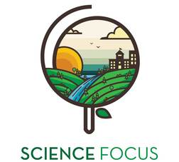

Topic
- Waste
- Local Food Production

Objective
- Learn about composting as a way to divert food waste from the landfill.
- Learn about making compost for food production. Our food scraps can go back to the earth, completing the food cycle, by being composted.

Environmental Education Activity

Age/Grade Range
- 8-18+

Group Size
- Maximum: 10 children

Time
- Set-up: 20-30 minutes
- Activity: 30 minutes

Materials
- Plastic bins with lids (one per child)
- Bedding (newspaper, leaves, straw, peat moss, coir- coconut fiber, etc.)
- Spray bottle with water
- Food scraps
- Red wiggler worms

Set Up
- Drill or small cut lots of holes in the lids of the plastic bins for air. Drill or cut a few small holes in the bottom of the plastic bins for drainage.

Activity Directions
- Line the bin with 3 or 4 full sheets of dry newspaper.
- If using newspaper for bedding, shred the newspaper into long thin strips.
- Add bedding of your choice to the bin and moisten with the spray bottle. Bedding should be moist like a wrung-out sponge. To test if there is enough moisture, pick up a handful of bedding and squeeze. Just a few drops of water should come out. If too dry, add more water. If too wet, add more bedding.
- Place a couple handfuls of food scraps to the bin. To aid the worms with breaking down the food, the scraps can be cut up into smaller pieces.
- Add worms to the bin. Gently cover the worms with some bedding.
- Put lid on bin and place bin in a cool, dark place, away from direct sunlight.

