LESSON PLAN: A Key to Frogs and Toads of the NWT
Lesson Subject: Science Topic: Diversity of Living Things
Date: Spring, Location: Classroom with optional field work
Length: 60-120 mins
Objective : To introduce classification keys and amphibians in the NWT

Introduction: Classification keys can be very important in research to help with the identification and monitoring of specific species. This lesson aims to teach students about how keys are created and have them create their own key to identify NWT frog species.

Supplies/Materials:
Computers to access FrogWatch information Sample Classification Key (see resources)
Pictures of Frogs and Toads in the NWT (FrogWatch or Amphibians in the NWT)

Curriculum Objectives:
Diversity of Living Things – vertebrates, classification, use of keys, adaptations

Hook: Show sample classification key. Ask students to determine how the key works and what features are used to identify the different groups of animals.

Intro Activity: Let students know they will be developing a key for frogs and toads of the NWT, as these animals are good indicators of environmental health. Have them brainstorm in small groups what they know about frogs and toads in general and what features might help them tell different frogs/toads apart. Create a list on the board.

Main activity:
- Divide students into small groups or partners and have them go to the FrogWatch site and look up the frogs and toads for the area.
- Have them work together to create a key that would help someone distinguish one from another.

Independent Student work:
Have students choose a frog or toad living near your community to research in further detail, including learning its vocalisations.

Homework:
If the season is appropriate encourage students to try and locate their frog and make observations to submit to Frog Watch
Conclusion/Review:
Distribute pictures of frog/toad species in the NWT without labels. Have students exchange keys and try to identify the species.

Resources:
1. Sample Classification key from: http://a.files.bbci.co.uk/bam/live/content/zyp4q6f/small
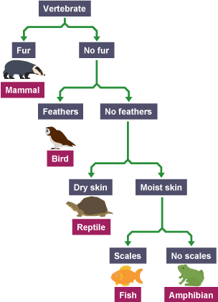

FrogWatch: https://www.naturewatch.ca/frogwatch/

Amphibians in the NWT: http://www.nwtspeciesatrisk.ca/sites/default/files/pdf/amphibians_reptiles_pamphlet.pdf

