My Own Local Bistro
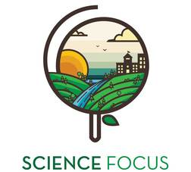

Topic
- Local Food Production

Objective
- Think about using local foods as staples in meals

Environmental Education Activity

Age/Grade Range
- 10-14

Group Size
- No maximum or minimum
- In pairs or small groups

Time
- Set-up: 5 minutes
- Activity: 20 minutes

Materials
- Menu planner

Set Up
- Photocopy menu planner (one pre group)

Activity Directions
- As a large group, ask youth what foods are produced, harvested and gathered locally?
- Ask youth to form groups of 2 or 3. Distribute the menu planner to each group. Ask the youth to create a menu for a three-course meal using as many local ingredients as possible.

Menu Planner
Main Dish: __________________________________________________________________________
Ingredients: _________________________________________________________________________
___________________________________________________________________________________
___________________________________________________________________________________

Dessert: ____________________________________________________________________________
Ingredients: _________________________________________________________________________
___________________________________________________________________________________
___________________________________________________________________________________

Local Ingredients:
My Local Food Bistro
Menu
Appetizer: _________________________________________________________
Ingredients: _______________________________________________________
__________________________________________________________________
__________________________________________________________________

