What are my Foods Made of?
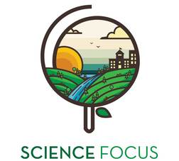

Topic
- Local Food Production

Objective
- Identify what processed foods are made of

Environmental Education Activity

Age/Grade Range
- 5-8

Group Size
- No max or minimum
- Individual activity

Time
- Set-up: 5 minutes
- Activity: 20 minutes

Materials
- Pencil crayons, markers, crayons for colouring
- Activity sheet (one per youth)

Set Up
- Photocopy activity sheet

Match Me
Connect the plants and animals of the left to the corresponding foods on the right. Colour me too!
