Where in the World

Environmental Education Activity

Resource Sheet

Emissions Calculator
- Check the food label: Where did your product come from?
- Look it up the location on the chart: how many kilometers did your food travel?
- Which method of transportation did your food use to get here? Plane, boat, train, truck?
- Use the table below to calculate the emissions produced from the transport of your food:
Grams of GHG emissions per 1 km traveled for each 1 kg of food
Plane | 1.1010g
Truck | 0.2699g
Boat | 0.1303g
Train | 0.2699g

For example, If a 1kg of tomatoes from Mexico travels 4200km by truck to reach your community the calculation would be done as follows:
1kg tomatoes x 4200km x 0.2699g GHGs/ km = 1129.8g GHGs for 1 kg of tomatoes
That means that 1.1298kg of GHGs are emitted to the atmosphere, the same amount as going for a 3.6km in an average Canadian Car.

World Map
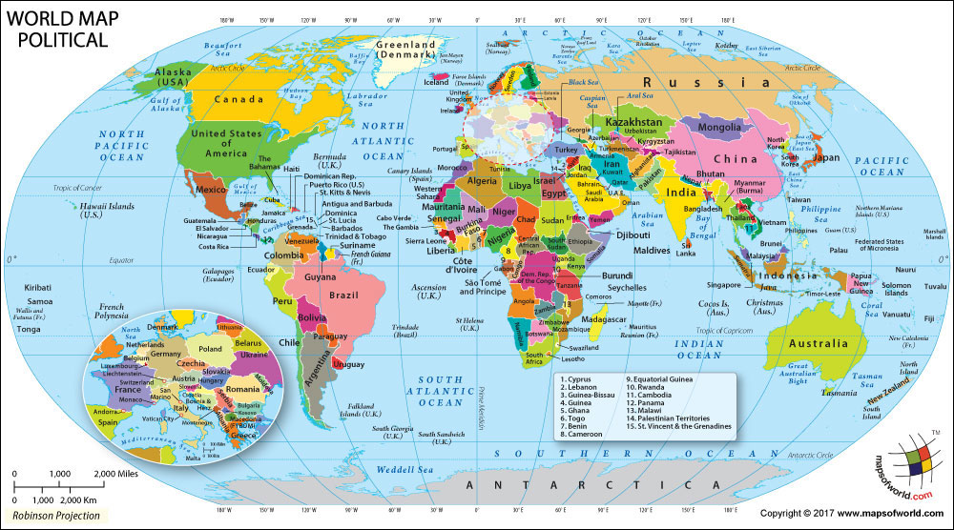

What’s in My Grocery Bag?
Apple  Product of New Zealand  Could this be produced locally? | Banana  Product of Costa Rica  Could this be produced locally? | Beef  Product of Alberta  Could this be produced locally? | Wheat Flour  Product of Saskatchewan  Could this be produced locally?
Tomato  Product of Mexico  Could this be produced locally? | Eggs  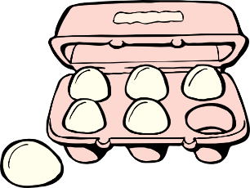  Product of Hay River  Could this be produced locally? | Potatoes  Product of PEI  Could this be produced locally? | Carrots  Product of Florida  Could this be produced locally?
Mango  Product of India  Could this be produced locally? | Grapes  Product of Spain  Could this be produced locally? | Wild Cranberries  Product of the bush near my community | Peas  Product of my garden
Orange  Product of Uruguay  Could this be produced locally? | Fair Trade Coffee  Product of Ethiopia  Could this be produced locally? | Fair Trade Chocolate  Product of Ecuador  Could this be produced locally? | Kale  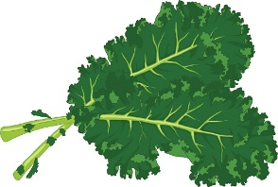  Product of California  Could this be produced locally?

Distance Chart
Product | Imported Distance (Km) | Method of Transport
Apple- New Zealand | 13,131 | Boat
Banana- Costa Rica | 8,815 | Plane
Beef- Alberta | 1,455 | Truck
Flour- Saskatchewan | 2,206 | Truck
Tomato- Mexico | 5,455 | Truck
Eggs- Hay River | 481 | Truck
Potatoes- PEI | 6,140 | Truck
Carrots- Florida | 6,280 | Truck
Mango- India | 9,886 | Plane
Grapes Spain | 7,063 | Plane
Orange- Uruguay | 11,942 | Plane
Coffee- Ethiopia | 11,744 | Plane
Chocolate- Ecuador | 7,732 | Boat
Kale- California | 4,228 | Truck

