Where in the World Does our Food Come From?
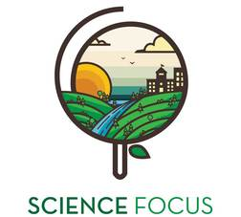

Topic
- Local Food Production

Objective
- Explore where our food comes from
- map out the distance food travels to reach your community
- gain an understanding that food can be grown close to home, rather than imported from a great distance

Environmental Education Activity

Age/Grade Range
- Age: 12-15

Group Size
- No maximum or minimum
- Small groups activity

Time
- Set-up: 5-10 minutes
- Activity: 30 minutes

Materials
- Photocopies of a world map- one for each group
- Food label chart- one set for each group
- Emissions calculator- one per group
- Food distance chart- one per group
- Notepad and pencil to record findings- one per group

Set Up
- Prepare materials

Activity Directions
- Divide your group into smaller groups of 3-5.
- Give each group a world map, food label chart, emissions calculator and food distance chart
- Identify the different food items with all the youth and have volunteers read where they come from and locate the origin on the map. Get the groups to write the food items on the map for visual reference.
- Have the youth refer to the food distance chart and the emission calculator to calculate the total amount of emissions it took to get that food item to your community.
- As a class, compare the emissions from food from abroad to food items that could have been purchased locally.

Questions/Points of Discussion
- On average, the food we eat travels 2400 km before it reaches our plate.
- Which foods that we looked at during this activity could have been bought locally?
- What could we do during the winter months to still use local produce?
- Do we need to eat all these imported products?

