The Travelling Tomato

Environmental Education Activity

Resource Sheet

Cut outs

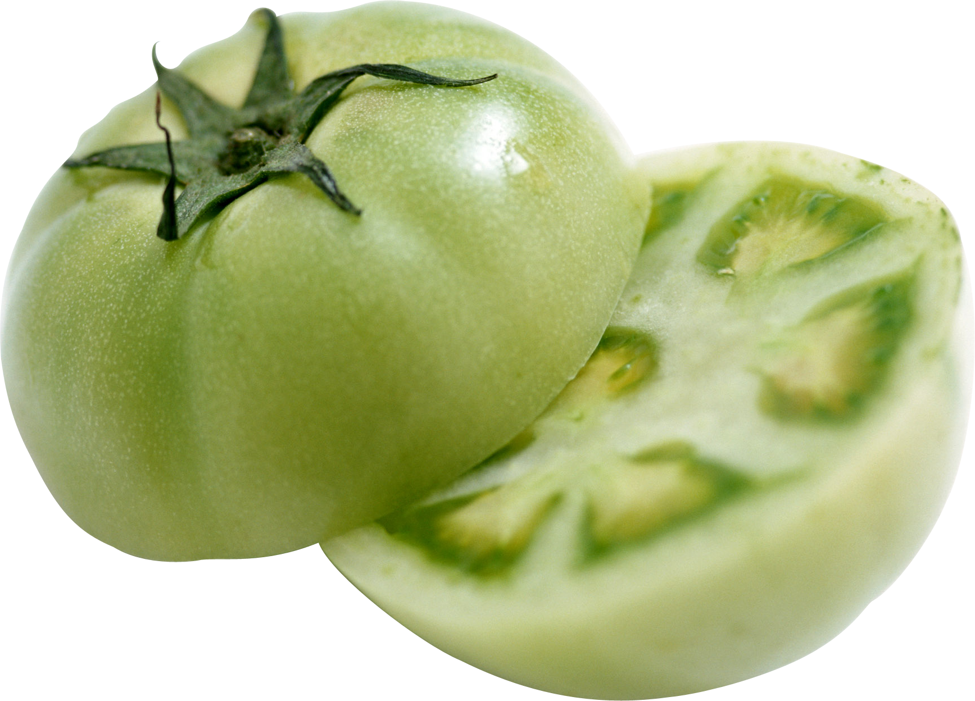

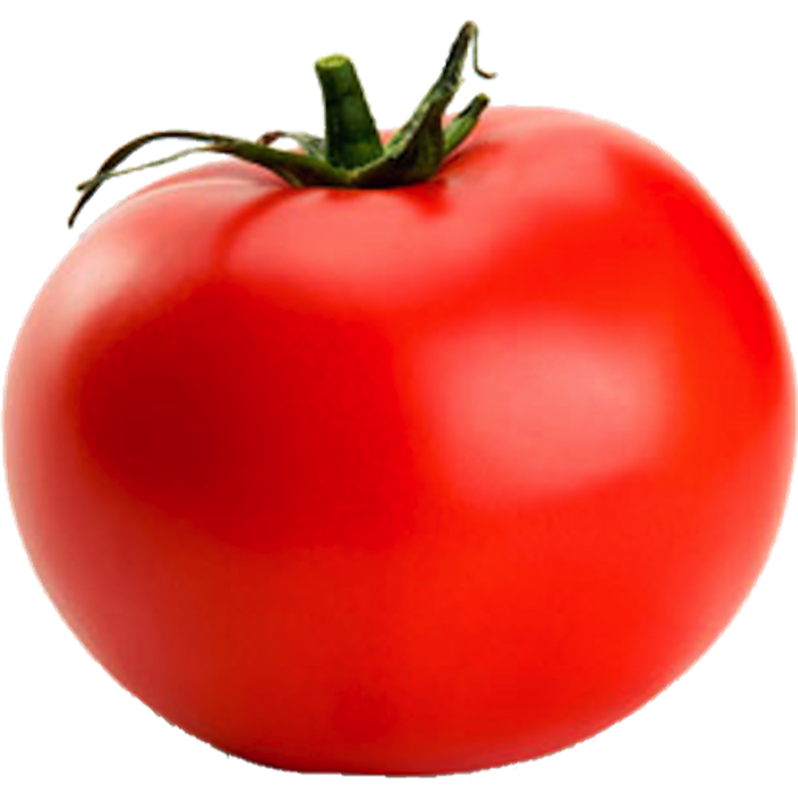

Part 1 Role Cards
#1 Mexican Farmer (Carlos)  “Hi I am Carlos, the Farmer. Look at all these green tomatoes I have to pick today. They’re not ripe yet, but I have to pick them like this so that they won’t over ripen and rot on the long journey to the grocery store. But first I need to spray them with pesticides to keep the bugs away”. | #2 Boss (Juan)  “Hi, I am Juan, Carlos’ boss. Thank you for the tomatoes, Carlos. Keep working hard, we have lots of deliveries to make. These tomatoes have to be in Canada by next week”.
#3 Truck Driver (Mark)  “Hi I am Mark and I truck the tomatoes from Mexico. It’s a long drive to Canada. These tomatoes have thousands of kilometres to travel.” | #4 Warehouse Owner (Sally)  “Hi I am Sally! These tomatoes are still green! Before I can deliver them to the grocery store I need to use ethylene gas to speed-up the ripening process. Ethylene occurs naturally in plants when they are ripening and is responsible for changing tomatoes from green to pink to red.”
#5 Grocery Store Owner (Judal)  “Hi I am Judal. Wow, these tomatoes have traveled more than I have! It seems strange to buy a product from far away that we could have grown in our own community.” | #6 Consumer (Kim)  “Hi I am Kim. Here I am in the grocery store. I need to find some tomatoes to make spaghetti  sauce. Here’s one...it’s kind of hard, and from far away...but it’s the only tomato available.”

Part 2 Role Cards
#1 Local Organic Farmer (Sylvia)  “Hi I am Sylvia and I live on a farm just outside your community. I’ve been taking care of this tomato since I planted it in the spring. Now it’s red and ripe to pick. Tomorrow I’ll take it to the  local farmers market and sell it to someone from the community.” | #2 Consumer (Michael)  “Hi I am Michael. I love coming to the farmer’s market...look at all this beautiful food! I also get to see friends, and meet the people that grow, harvest, fish and hunt for the food I eat. Hi Sylvia, your tomatoes look great, I think I’ll buy some for making spaghetti sauce.”

