Germinating Bean and Pea Seeds
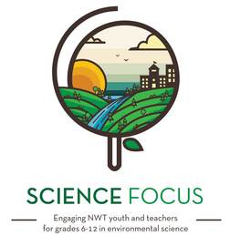

Topic
- Local Food Production

Objective
- See firsthand how seeds germinate and start to grow

Environmental Education Activity

Age/Grade Range
- 5-15+

Group Size
- No maximum or minimum

Time
- Set-up: 5 minutes
- Activity: 20 minutes + 2 weeks

Materials
- Bean and/or pea seeds, 3 or 4 per child (this activity can be done with other seeds, but beans and pea seed work best)
- Clear glass mason jars or clear plastic cups, 1 per child
- Paper towel
- Masking tape and marker
- Spray bottle or other watering device

Set Up
- Set up materials
- Watch the instructional video (4 minutes) for this activity: http://www.youtube.com/watch?v=U9SWwnWe0VQ

Activity Directions
- With masking tape, get the children to write their name, type of seed and date on the side of the jar or cup.
- Fill the inside of the jar with paper towels. There should be enough paper towels in the jar that they are snug against the sides of the jar.
- Pour or mist water into the paper towels until they are all moist, but there is no standing water in the bottom of the jar. Pour out any standing water.
- Place a seed between the paper towel and the side of the jar, so that the seed is visible through the glass. Repeat with 2 or 3 more seeds, spaced out in the jar.
- Set cups in a sunny place, that is away from any cold drafts.
- Over the next 2 weeks, observe the seeds every couple of days. Get the children to note or draw the changes in the seeds.
- Keep the paper towels damp as they dry out over the 2 weeks.
- After 2 weeks, the seeds can be transplanted planted in to small pots

Extension
- This activity can be paired with lessons about seed biology

