Interview with a Honeybee
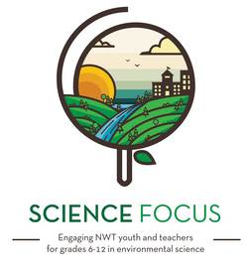

Topic
- Ecology & Animals
- Local Food Production

Objective
- A short skit to teach children about honeybees
- Learn about a pollinator important to local food production

Environmental Education Activity

Age/Grade Range
- 8-13

Group Size
- No maximum or minimum

Time
- Set-up: 0-20 minutes
- Activity: 5 minutes

Materials
- Lines for skit
- A Honey bee puppet or toy (optional)

Set Up
- Go over lines of skit

Delivery Tips
- This skit can be run with two facilitators or get a helper from the audience.

Skit
Honeybee: Hello, I am Henry the Honeybee. Does anyone have any questions for me?
Child or facilitator: How do you eat, Henry the Honeybee?
Honeybee: I use a feeding tube in my mouth called a “proboscis” to suck nectar from flowers to make honey. I keep my feeding tube folded away when I am flying.
Child or facilitator: What do you eat?
Honeybee: I eat both the flower nectar and the flower pollen which is a yellow grain-like powder on plants. I carry the nectar back in my honey stomach. I have two stomachs! I carry the pollen back to my home on my back legs. I mix the nectar and pollen for my food. Any extra food that I don’t eat is stored as honey in wax cells in my house called honey combs.
Child or facilitator: Where do you live?
Honeybee: I live in hives or nests in trees, bee boxes, or all kinds of places.
Child or facilitator: How do you travel?
Honeybee: I can walk with my legs and fly with my two sets of wings. I tell other bees where to find food by doing a special dance.
Child or facilitator: When are you awake?
Honeybee: I am awake during the daytime and have good eyes to see the sun, trees and flowers. I feel things with my antennae.
Child or facilitator: How do you reproduce?
Honeybee: The queen in my house lays eggs in the special honeycombs, called nurseries. The female bees care for the nurseries. The eggs hatch into larvae, then develop pupae, and finally become adults. The queen mates with male bees, called drones, outside the hive.

Modifications
- Children can create their own interview questions and answers using books, videos and other resources about bees.

