Yucky Worms
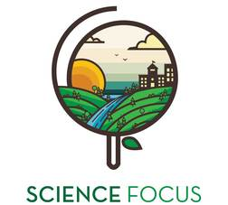

Topic
- Ecology and Animals

Objective
- Learn about worms in an active, hands-on way.

Environmental Education Activity

Age/Grade Range
- Age 6-8

Group Size
- Up to 30

Time
- Set-up: 5 minutes
- Activity: 15-20min

Materials
- Yucky Worms (book by Vivian French)
- Flashlight
- Worm bins

Set Up
- Try to clear as large space as possible where students will be able to gather in a large horseshoe formation. They will need some space to move around in.

Delivery Tips
- For larger groups, use this as a station paired with other activities.

Activity Directions
- Read “Yucky Worms”
- Be a Worm! Now the kids will all get to pretend to be worms:
  - Do worms have arms and legs? Nope! So snap your arms and legs to your bodies.
  - Worms have 2 types of muscle, one goes ‘laterally’ the whole length of their body and ones going around – to move they expand and contract these muscles like an accordion to inch forward: pretend you are inching around in the soil!
  - Do worms have eyes? Nope! Close your eyes
  - How do worms find food? Wiggle around trying to just sense food with your head!
  - Turn on your flashlight. Open your eyes. There’s something scary coming! It’s the hot hot sun! Hide!!!
  - Oh we’re nice and deep in the ground, oh wait, it’s raining! We’ll drown if we don’t find high ground! Get up!!
  - One more thing – worms love being together in a community, so everyone come on in close and wiggle around together
- Look at the worms! Give everyone a worm to look at! Make sure they understand that a worm needs to stay moist or it will dry up and that they are sensitive so the kids can only use their pinky finger to touch them and not to squeeze.
  - What’s special about a worm –
  - Do they have skin like us, what’s special about it?
  - Which end is their head and which is their posterior?
  - How do they move?
  - Can you see some of their insides?
  - Do they have eyes?

Extension

Vermi-Compost activity?

