Simon Says Northern Animals
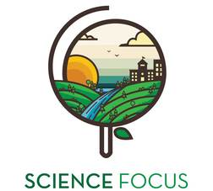

Topic
- Ecology and Animals

Objective
- Get the kids thinking about animals, and burn off some energy before heading into the rest of the activities.

Environmental Education Activity

Age/Grade Range
- Age 6-8

Group Size
- Up to 30

Time
- Set-up: 2 minutes
- Activity: 5-10min

Materials
- None

Set Up
- Clear a large space where students will be able to move around freely.

Delivery Tips
- This is best run as a warm up game.
- Pair with other Ecology and Animals activities.

Activity Directions
- This is a simple modification of the Simon Says game. Explain the different animal actions they will need to listen for. If you don’t say Simon Says before the call, they aren’t suppose to do the action.
- Calls:
  - Simon says be a: mosquito (run and buzz with one arm held out infront), moose (hands above head, walk heavily), fish (squiggle on the ground), raven (flap around running), wolf (howl like a wolf).
- Try and catch people who switch even when you don’t say Simon Says.

