Birds of Hay River
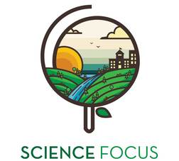

Topic
- Ecology and Animals

Objective
- Learn about birds that live in Hay River.
- Play some games.

Environmental Education Activity

Age/Grade Range
- 8-11

Group Size
- up to 20 students

Time
- Set-up: 30 minutes
- Activity: 1 hr

Materials
- 2 pairs of bird cards
- NWT bird checklists
- Map of Hay River
- Photos of birds of the area
- Origami/folding paper
- Binoculars
- Colouring sheet

Set Up
- Gather materials and prepare a map and bird cards.

Activity Directions
- Warm-up Game: Noah’s Ark (10min)
  - 2 sets of bird cards with the noise the bird makes on the back.
  - Hand them out – kids have to make the noise and try and find their partner. To make it harder, use blindfolds. To make it easier, add actions.
- Let’s find some birds! (15min)
  - How can you identify birds? Hand out bird survey checklists.
  - Go to the visitor centre to look at bird houses. Use binoculars and take 10 minutes to look for birds, write down the ones you see.
- Birds of Hay River (15min)
  - Explain about some really neat birds – migrating birds! What do they need? Specific habitats. What birds have they seen? Where?
  - Use airphoto map of Hay River and hand out the ‘Birds of Hay River’ pieces, have each kid decide where the bird lives/or where they can be seen on the map and put the picture in that place!
    - Swallow – under the bridge
    - Eagle – river valley
    - Raven – in town
    - Shore birds/seagulls – along the beach
    - Song birds/owls – in the forests
- Bird flight! Talk about different styles of flight. Make paper airplanes and have a flying contest!!
- If there’s time at the end have the kids do the Colouring sheet

Pairs Well With

Bird Beak Buffet

Print Outs
- Birds of Hay River Photos and Colouring Sheet

