Forest Bird Walk
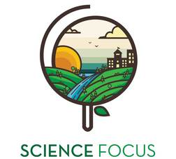

Topic
- Ecology and Animals

Objective
- Learn to identify local birds.
- Learn how to contribute to scientific knowledge through a citizen science network.
- Understand the importance of monitoring species to keep track of changes in the environment.

Environmental Education Activity

Age/Grade Range
- Grade 5-12

Group Size
- In pairs, small groups or as a large group activity (15-30 students)

Time
- Set-up: 30 minutes
- Activity: 1 hr

Materials
- Note paper or recording sheets, and pencils
- Bird field guides, or printed info sheets.
- Binoculars (optional)
- Cameras (optional)
- Devices with access to internet

Additional Considerations
- This is an outdoor activity, where students will observe birds, and then contribute to a real citizen science database.

Set Up
- Create an account on the eBird website, so that you and your class can submit your observations after the walk.
- Pick a nearby location where you and your class will collect the data.
- You may want to create a short slideshow of pictures of some NWT birds, or provide print-outs with pictures to give students an idea of what they are looking for before they go out.

Activity Directions
- Describe the activity to the class. Break into small groups, each with a recording sheet, a camera, and binoculars.
- Take the class for a bird walk, where students look for all the birds they can find. You may want to point out different habitat types (open rocky outcrop, grassland, forest, swamp/bog) and talk about what species might live in different habitats.
- Provide a checklist of common forest birds with pictures, or a worksheet for students to record or sketch their observations. Here are some examples:

- Common raven
- Bald eagle
- White crowned sparrow
- Yellow warbler
- Yellow-rumped warbler
- Sharp shinned hawk
- Ptarmigan
- Spruce grouse
- Rusty blackbird
- Red winged blackbird
- Bohemian waxwing
- Three toed woodpecker
- Dark eyed junco
- Boreal chickadee

- Return to class and tally up sightings from all groups. As a class submit the observations to the ebird database. ebird is a community of thousands of birders whose site-specific observations of birds have contributed to our understanding of birds around the world. Emphasize the importance of citizen science for conservation, and for recording the effects of climate change on bird species in the NWT.
http://ebird.org/content/ebird/about/

Extension – Connecting to Climate Change: Rusty Blackbird
- Background
- Climate change is having many effects on NWT species. Average temperatures are rising causing behavioural changes in many animals, including transient species like the rusty blackbird. For the rusty blackbird, scientists predict its range may shift northward as temperatures increase. It may arrive in the NWT earlier and stay longer into the fall. The forests of the NWT may become increasingly important habitat as its range shifts northward and its habitat becomes scarce in the South.
- The forest habitat where rusties make their home in the NWT is changing due to climate change. New species of birds, insects, and plants are moving north and each have their own small effect on the boreal forest community.
- Warmer temperatures also mean drier conditions. Wetlands may dry out reducing the preferred habitat for the rusty blackbird. These dry conditions in turn promote forest fires that burn hotter and longer. The open areas created by the fires can offer excellent hunting grounds for predators like falcons and hawks. For the rusty blackbird these effects may become key factors in the continued decline of the species in the future.
- Climate change can have many effects on the forest community and may become a very important factor affecting this species at risk in the years to come. It’s important that we keep track of the changes occurring in the forests because this knowledge will become important in protecting the rusty blackbird into the future.
- Citizen Science
- Here is a quick way to show the effects of climate change on the range of the rusty blackbird. Individual sightings submitted by birders can be used as a rough index of population size. The number of rusty blackbird sighting in the North appears to have increased. Could this be the result of their range shifting northward?

EBird Sightings of Rusty Blackbird
(flame icons mark birding hotspots)
1998-2007
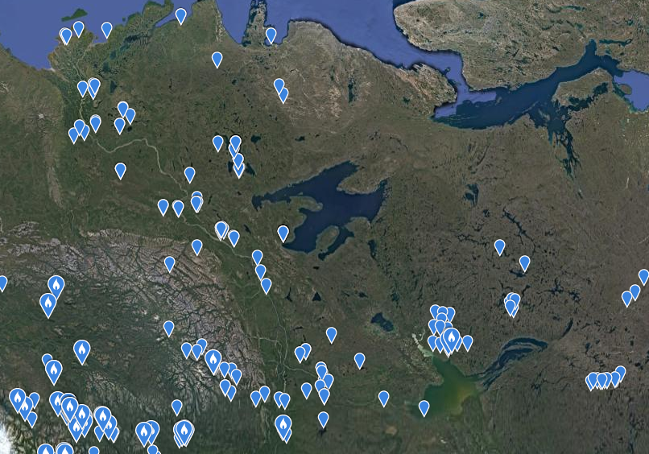

2008-2017
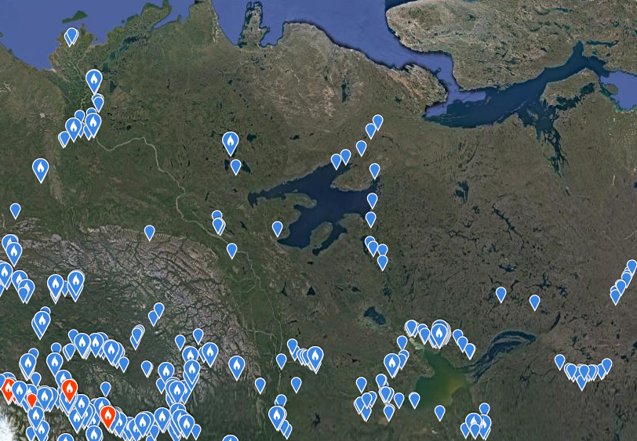
- These types of maps are easy to generate right on the eBird website. As an added activity have students go onto the eBird website and explore the interactive maps under the Explore Data tab.

