Seed Mosaics
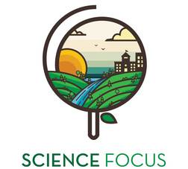

Topic
- Local Food Production

Objective
- Discover and explore a diverse array of seeds as they create unique mosaics

Environmental Education Activity

Age/Grade Range
- 5-10

Group Size
- Individual craft
- No maximum or minimum

Time
- Set-up: 20 minutes
- Activity: 30 minutes- 1 hr

Materials
- White glue
- Paintbrushes
- Cardboard, paper plates or any sturdy backing
- Variety of seeds of different colors and sizes
- Pencils or markers for designing picture

Set Up
- Draw figures, shapes or other designs on the cardboard or other backings (older children may want to draw their own designs).

Activity Directions
- Get children to paint glue in a small part of the design. Note: do not use too much glue, just enough to stick the seeds to backing
- Place desired seeds on the area with the glue. Repeat for the entire picture
- Have students analyze seeds as they work noticing different textures, shapes, colors and sizes.
- Allow to dry completely before displaying

