Food Miles
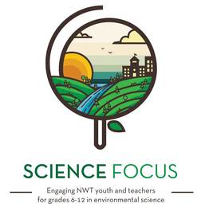

Topic
- Local Food Production

Objective
- A lot of the food consumed in the NWT is imported. This activity teaches kids about where their food comes from and how far it travelled to be on their plate
- Help kids make connections between food miles and GHG emissions

Environmental Education Activity

Age/Grade Range
- Ages: 10-18+

Group Size
- In pairs or small groups (with a device with access to internet in each group)
- No maximum or minimum group size

Time
- Prep time: 5-10 minutes
- Activity: 15-30 minutes

Materials
- Devices with access to internet
- Food with country of origin information on it
- Notebook
- World Map, string, pins (optional)

Set Up
- Check out the website: http://www.foodmiles.com/results.cfm

Activity Directions
- In groups, get kids to gather food items from their lunch or snacks. Look for stickers on produce such as apples or bananas or information on food packaging to find the food’s country of origin.
- Get kids to go to http://www.foodmiles.com/results.cfm on their device to find out how many kilometers their food travelled and how many CO2 emissions it took for the food to be on their plate. If there are multiple food items, get students to note and add up all the ‘food miles’ in their lunch.
- (optional) With the whole group, get the kids to name the countries that their food is from. On a world map, put pins in the countries as well as one for your community. Tie string from the different countries to your community pin.

Questions/Points of Discussion
- Ask the kids, how they could reduce the C02 emissions related to their food?
- For older kids, ask them to bring more detail into their maps. Where was the raw food grown? Where was the food processed? Where were the distribution centres along the way?

Pairs Well With
- Activities for growing/making your own food

